41.30: 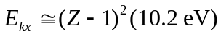
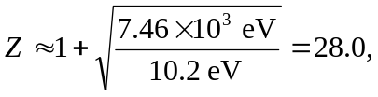
which corresponds to the element Nickel (Ni).

